Reverberation
Reverberation (reverb) is one of the most often used effects in audio production. It is often implemented as convolutional reverb, which adds reverberation to an audio stream by convolving that signal with a room impulse response, either recorded or simulated. In this Chapter, we will focus on how to simulate reverb using the ConvolverNode. We first explain the nature of reverberation. Then a detailed description is given of how reverb is implemented as an audio effect using block-based fast convolution. The specifics of how this is used for the ConvolverNode are then presented. Three source code examples are given. The first illustrates typical use of the convolver node, where a source is convolved with a simulated impulse response. The second example illustrates a minor issue with use of the ConvolverNode's normalize parameter. In this example, the impulse responses are stored in wav files. The final example shows how FIR filters can be implemented using convolution.

Theory
In a room, or any acoustic environment, there is a direct path from any sound source to a listener, but sound waves also take longer paths by reflecting off the walls, the ceiling or objects, before they arrive at the listener, as shown in Figure 14.1. These reflected sound waves travel a longer distance than the direct sound and are partly absorbed by the surfaces, so they take longer to arrive and are weaker than the direct sound. These sound waves can also reflect off of multiple surfaces before they arrive at the listener. These delayed and attenuated copies of the original sound are what we call reverberation, and it is essential to the perception of spaciousness in the sounds.
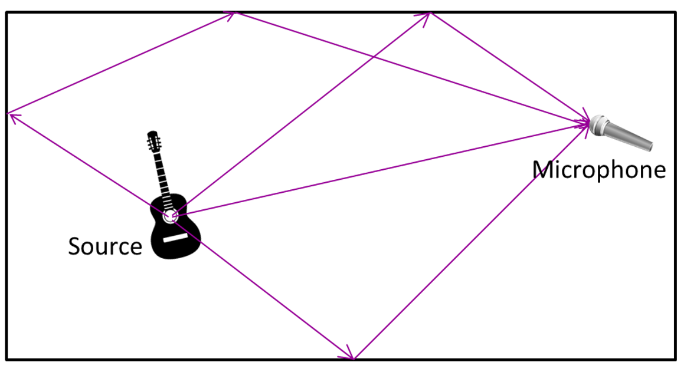
Figure 14.1. Reverb is the result of sound waves traveling many different paths from a source to a listener.
Reverberation is more than just a series of echoes. An echo is the result of a distinct, delayed version of a sound, as could be heard with a delay of at least 40 milliseconds. With reverberation from a typical room, there are many, many reflections, and the early reflections arrive on a much shorter time scale. So these reflections are not perceived as distinct from the sound source. Instead, we perceive the effect of the combination of all the reflections.
Reverberation is also more than a simple delay device with feedback. With reverb the rate at which the reflections arrive will change over time, as opposed to just simulating reflections that have a fixed time interval between them. In reverberation, there are a set of reflections that occur shortly after the direct sound. These early reflections are related to the position of the source and listener in the room, as well as the room’s shape, size and material composition.. The later reflections arrive much more frequently, appear more random, usually decay exponentially, and are difficult to directly relate to the physical characteristics of the
room. These late reflections give rise to diffuse reverberation. An example impulse response for a room is depicted in Figure 14.2. Each vertical line marks when the original sound is repeated, and the height of each of these lines is the amplitude of the sound at that time.
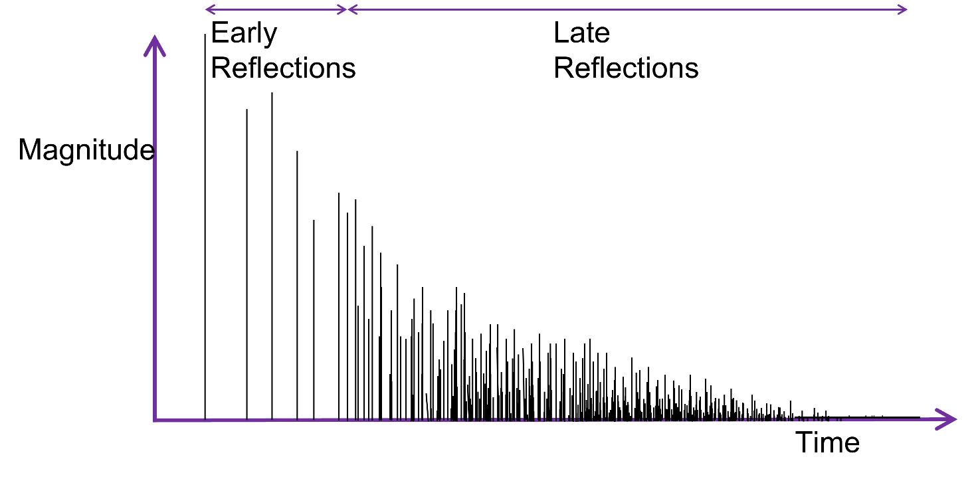
Figure 14.2. Impulse response of a room.
A measure that is often used to characterize the reverb in an acoustic space is the reverberation time, often denoted RT₆₀. This is the time that it takes for sound pressure level or intensity to decay by 60dB, i.e., 1/1,000,000th of its original intensity, or 1/1000th of its original amplitude. A long reverberation time implies that the reflections remain strong for a long time before their energy is absorbed. The reverberation time is associated with room size. Small rooms tend to have reverb times on the order of hundreds of milliseconds, though this can vary greatly depending on the acoustic treatment and other factors. Larger rooms will usually have longer reverberation times since, on average, the sound waves will travel a larger distance between reflections. Concert halls typically have reverberation times around 1.5 to 2 seconds. Cathedrals and other highly reverberant environments may have reverb times of more than 3 seconds.
It is possible to construct a large room with short reverberation time, and vice versa. The reverberation time is dictated primarily by the size of the room and the surfaces in the room. The surfaces determine how much energy is lost or absorbed each time the sound is reflected. Highly reflective materials, such as a concrete or tile floor, will result in a long reverb time. Absorptive materials, such as curtains, cushions or heavy carpet, will reduce the reverberation time. People and their clothing absorb a lot of sound. This explains why a room may sound 'bigger' during a soundcheck prior to a performance, but smaller and more intimate once the audience has arrived. The absorptivity of most materials usually varies with frequency, which is one reason why the reverb time is dependent on the spectral content of the source signal (formal measurement of reverb time is performed using an impulse or turning off a noise generator). The air in the room will also attenuate the sound waves, reducing the reverberation time. This attenuation is a function of temperature and humidity and is most significant for high frequencies. Because of this, many audio effect implementations of reverb will include some form of low pass filtering, as will be discussed later in this chapter.
Another important measure of reverberation is the echo density, defined as the frequency of peaks (number of echoes per second) at a certain time t during the impulse response. The more tightly packed together the reflections are, the higher the echo density. If the echo density is larger than 20-30 echoes per second, the ear no longer hears the echoes as separate events, but fuses them into a sensation of continuous decay. In other words, the early reflections become a late reverberation.

Direct and Reverberant Sound Fields
The reverberation due to sound reflection off of surfaces is extremely important. Reverberation keeps sound energy contained within a room, raising the sound pressure level and distributing the sound throughout. Outside in the open, there are far less reflective surfaces, and hence much of the sound energy is lost.
For music, reverberation helps ensure that one hears all the instruments, even though they may be at different distances from the listeners. Also, many acoustic instruments will not radiate all frequencies equally in all directions. For example, without reverberation the sound of a violin may change considerably as the listener moves with respect to the violin. The reverberation in the room helps to diffuse the energy a sound wave makes so that it can appear more uniform when it reaches the listener. But when the reverberation time Why use Reverb?
We usually inhabit the reverberant field, with many sources of reverberation already around us. Yet it is still useful to add reverb to recordings. We often listen to music in environments with very little or poor reverb. A dry signal may sound unnatural, so the addition of reverb to recordings is used to compensate for the fact that we cannot always listen to music in well-designed acoustic environments.The reverberation in a car may not adequately recreate the majestic sound of a symphony orchestra. And when listening over headphones, there is no reverberation added to the music.

Convolutional Reverb

Convolution and fast convolution
Convolution is an important mathematical technique for combining two signals. By convolving a signal with a room impulse response, we can create the reverberated signal as it would be heard in a room. Given an input signal s, the filtered output r is the result of the convolution of s by the finite impulse response h[0]… h[n-1];
$r[n]=(s*h)[n]=\sum_{k=0}^{N-1}{s[n-k]h[k]}$.
However, a naïve implementation of this is far too slow. We need to do sizeof(X)*sizeof(Y) operations, which is order N². For realistic simulation of a natural environment, the required impulse response often lasts more than a second. For processing one sample with convolutional reverb, addition and accumulation operations must be performed on the entire length of the impulse response. Thus, assuming a 48 kHz sampling frequency and an impulse response of just one second, roughly 2.3*10⁹ adds and multiplies are required each second. Fast convolution provides a means to address this complexity issue.
The fast convolution uses the well-known convolution theorem: performing multiplication in the Fourier domain is equivalent to performing convolution in the time domain (and vice-versa).
$$r=s*h↔R=S⋅H$$$→r=F^{-1}F\left(s\right)⋅F\left(h\right)$.
That is, rather than convolving two signals together directly, one can compute their Fourier transforms, multiply them together, and then take the inverse Fourier transform. This may seem like more steps, but the Fast Fourier Transform (FFT) can be used, which offers vast efficiency savings over convolution operations. Whereas convolving two signals of length N requires N² operations, the FFT requires on the order of Nlog(N) operations. Again assuming a sampling frequency of 48 kHz and an impulse response of one second, only about 10⁶ operations are needed each second if this Fast Convolution is used.

Block-based convolution
The main approach to performing fast convolution on a real-time signal is the overlap and add method. The input signal s is cut into blocks of length N. Each block is convolved with the impulse response h of length N as shown in Figure 14.3.
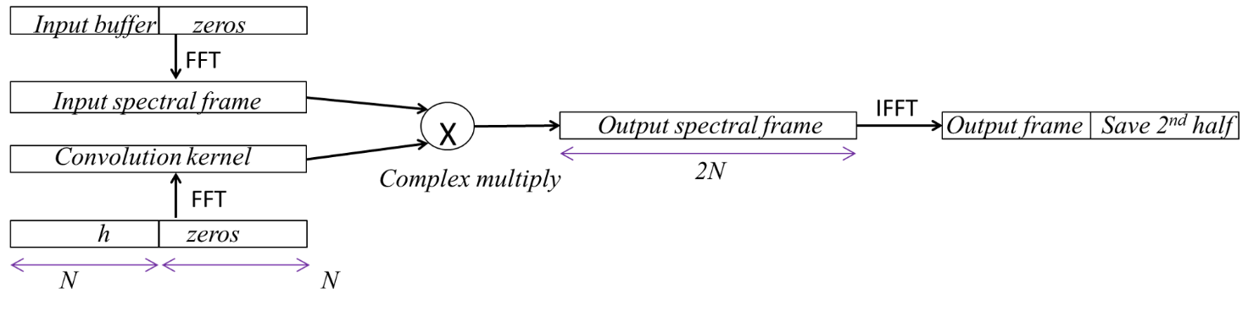
Figure 14.3. One block convolution, as implemented in block-based convolutional reverb. Each block is convolved with the impulse response h of length N.
This convolution is performed by zero padding the input signal block of length N in order to perform a 2N long Fourier transform. As a result, the fast convolution of one block with h produces a filtered signal of length two blocks.

Overlap and add
When convolving an input audio stream of unknown (or theoretically infinite) length, the overlap-add approach (Stockham Jr, 1966) is used. This involves chopping the input stream into pieces of length N, performing the convolution on each piece, then re-constructing the output signal by delaying each result and summing.
A standard overlap-add FFT convolution uses an FFT of size 2N, created by zero-padding the length N convolution kernel, to perform each convolution operation in the diagram below.
So, the k^{th} output block is obtained by adding together the tail of the convolution of the (k-1)^{th} block and h and the head of the convolution of the k^{th} block and h. This is shown for the first few blocks in Figure 14.4. To further improve performance, the Fourier transform of h can be pre-computed and reused until h is changed.
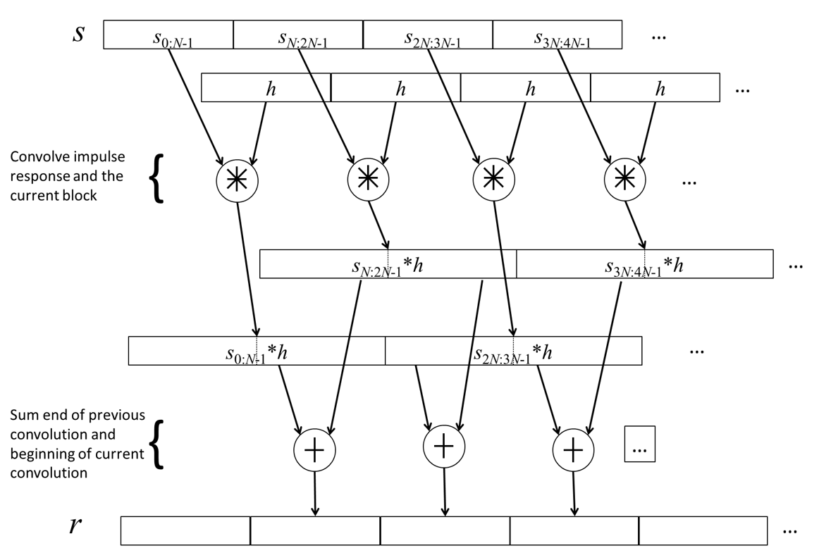
Figure 14.4. Partitioned convolution for real-time artificial reverberation.
Note that the k^{th} output block will be ready at the earliest at time (k+1)N. This minimum delay of one block size can be problematic. For instance if the impulse response lasts one seconds, a device that uses this overlap and add fast convolution method will have at least one second of delay. Also, blocks are convolved with the full impulse response, which can be quite computational.

Physical meaning
The partitioned convolution has a simple physical interpretation. Suppose h is a room impulse response and that convolutional reverb is applied to the input signal. Assuming a source produces a sound frame at time t, the direct path brings this frame to the listener. The other paths have reflections from the walls and ceiling, resulting in modified versions of the original frame with different attenuation and delay. The delays depend on the length of the path, including the number of reflections.
If sounds are produced continuously, then at any point in time a listener will hear the direct sound and delayed and transformed versions of previous sounds. The partitioned convolution is just an expression of this phenomenon. That is, at any point in time the sum is made over the length of the filter h plus the length of the last block. Since input blocks are convolved with h, we effectively obtain delayed and transformed version of sounds that were emitted in the past.

Convolution implementation
Creating an optimized real-time convolution engine is one of the more challenging parts of the Web Audio API implementation.

Nonuniform partitioned block convolution and other optimizations
One issue with the partitioned convolution is the partition size. Since it is based on convolving with the whole impulse response, there is still a lot of processing and latency. The naïve overlap-add FFT convolution mentioned above incurs a substantial input to output latency on the order of N samples. Also, the size of the FFT would still be large. For example, with an impulse response of 1 seconds at 48 Khz, N would equal 2¹⁷=131,072.
Gardner (Gardner, 1994) developed a solution to the high delay issue that uses the same idea as fast convolution. Since the input signal is partitioned into blocks, the impulse response can also be partitioned. Block convolution is then performed on the appropriate combination of input blocks and filter blocks and summed in order to produce the desired output. This efficient approach relies on a fast convolution that is performed many times, but on smaller blocks. The best approaches use different size FFTs and a direct convolution for the initial (leading) portion of the impulse response to achieve a zero-latency output.
After all this optimization, performance is real-time on a modern, standard CPUs.

Convolution Engine
Under the hood, the Convolution engine uses some low level building blocks, an FFTConvolver to do short convolutions and ReverbConvolver.
The FFTConvolver is able to do short convolutions with the FFT size N being at least twice as large as the length of the short impulse response. It uses the block-based convolution procedure described in Figure 14.3 and Figure 14.4. However because of computational performance and its inherent latency of N/2 samples, it is not suitable for long convolutions.
The ReverbConvolver is able to perform very long real-time convolutions on a single audio channel. IT uses the nonuniform partition blocks described above. It has multiple FFTConvolver objects as well as an input buffer and an accumulation buffer. It's possible to get a multi-threaded implementation by exploiting the parallelism, and the leading sections of the long impulse response are processed in the real-time thread for minimum latency. In theory it's possible to get zero latency if the very first block is processed using direct, time-domain convolution.

Multi-channel convolution
A convolution reverb typically involves two convolution operations, with separate impulse responses for the left and right channels in the stereo case. For 5.1 surround, at least five separate convolution operations are necessary to generate output for each of the five channels.

Channel Configurations for Input, Impulse Response and Output
Implementations support the following configurations of impulse response channels in a ConvolverNode to achieve various reverb effects with 1 or 2 channels of input.
As shown in Figure 14.5 depicts the supported input and output channel possibilities for mono and stereo playback where the number of input channels is 1 or 2, and the number of channels in the buffer is 1, 2, or 4.. Several cases are worth highlighting here.
When single channel convolution operates on a mono audio input, as in top left, it uses a mono impulse response, and generates a mono output. Top right is stereo to mono convolution, but note that the output is two channels since the convolver node only produces mono output for the case where there is one input channel and one channel in the buffer. A channel merger could be used if one wants two channel input to one channel output.
Middle left depicts mono to stereo convolution, requiring convolving with different impulse responses for left and right ear. Middle right depicts stereo to stereo convolution, with one buffer for each input channel. The last case is ‘true stereo’ convolution, requiring four buffers, so that each input channel has a different convolution applied for its contribution to each output. Applied correctly, this gives the most realistic reverb.
If you want other matrixing options, you can use the ChannelSplitterNode, multiple single-channel ConvolverNodes and then a ChannelMergerNode.
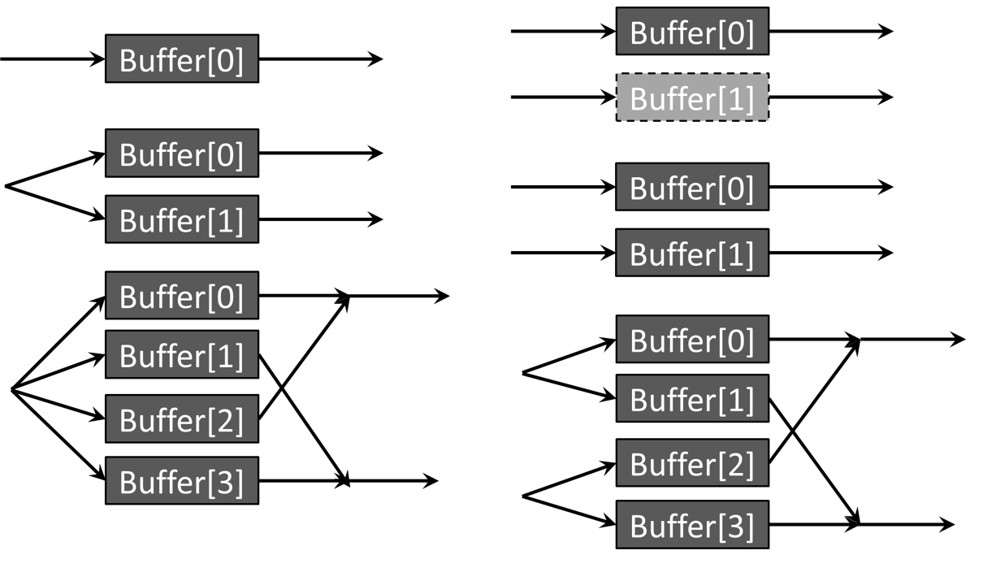
Figure 14.5. Supported input and output channel count possibilities for mono inputs (left) and stereo inputs (right) with 1, 2 or 4 channels in the buffer.

The Convolver Node
The Web Audio API provides an easy way to apply convolution using the ConvolverNode. This node applies a linear convolution effect given an impulse response. It takes an impulse response buffer, which is a regular AudioBuffer with the impulse response file loaded into it.
The impulse response acts like a very high order filter (like the IIRFilterNode), but it only has feedforward coefficients.
It’s also possible to generate these impulse responses synthetically, but this topic is outside of the scope of this book.
The input of this node is either mono (1 channel) or stereo (2 channels) and cannot be increased. Connections from nodes with more channels will be down-mixed appropriately. The ConvolverNode produces a mono output only in the single case where there is a single input channel and a single-channel buffer. In all other cases, the output is stereo. In particular, when the buffer has four channels and there are two input channels, the ConvolverNode performs matrix "true" stereo convolution.
See the channel configuration diagrams
The node only has 2 parameters.
- buffer is the desired audio buffer for convolution with the input. The initial value is null. The buffer numberOfChannels must be 1, 2, 4, and the sampleRate of the buffer must be the same as the sampleRate of the AudioContext. If the buffer is set to a new buffer, audio may glitch. One way to get around this is to create a new ConvolverNode to replace the old one, and cross-fade between the two.
- normalize is a Boolean which defaults to true. It controls whether the impulse response will be scaled by an equal-power normalization. Normalization results in a more uniform output level from the convolver when loaded with diverse impulse responses.
The ConvolverNode will first performs a scaled RMS-power analysis of the audio data contained within buffer to calculate a normalizationScale . The RMS power is given by,
$$P_{RMS}= \sqrt{{\sum_{c=0}^{C-1}{\sum_{n=0}^{N-1}{{b[n]}^{2}}}}/{CN}}$$
The scaling factor is then 1/P_{RMS} times a constant (see the Web Audio API specification), which is intended to make the convolved signal roughly the same perceived volume as the unprocessed signal. Scaling is further divided by 2 if numberOfChannels = 4, to provide true-stereo compensation.
During processing, the ConvolverNode will take this normalizationScale value and multiply it by the result of the linear convolution resulting from processing the input with the impulse response (represented by the buffer) to produce the final output.
If normalize is set to false, then the convolution will be rendered without scaling of the impulse response. That is, the ConvolverNode will perform a linear convolution given the exact impulse response contained within the buffer.

Example – Simulating reverb
Reverb: <input type='checkbox' id='ReverbCheck'><p>
<button id='Start'>start</button>
<script>
var context = new AudioContext()
var source = new OscillatorNode(context,{type:'sine'})
var amplitude = new GainNode(context,{gain:0})
var impulse=impulseResponse(3,1)
var convolver = new ConvolverNode(context,{buffer:impulse})
source.connect(amplitude)
source.start()
Start.onclick = function() {
context.resume()
amplitude.disconnect()
convolver.disconnect()
if (ReverbCheck.checked) {
amplitude.connect(convolver)
convolver.connect(context.destination)
}
else amplitude.connect(context.destination)
amplitude.gain.value=1
amplitude.gain.setValueAtTime(0,context.currentTime+0.05)//pulse lasts 50 ms
}
function impulseResponse(duration,decay) {
var length = context.sampleRate * duration
var impulse = context.createBuffer(2,length,context.sampleRate)
var IR = impulse.getChannelData(0)
for (var i=0;i<length;i++) IR[i]=(2*Math.random()-1)*Math.pow(1-i/length,decay)
return impulse
}
</script>

Code example 14.1. ConvolutionReverb.html, example use of a convolver node to simulate reverb.
In Code example 14.1, we simulate reverb by convolving a short duration signal with a synthesized impulse response. An oscillator is created, connected to a gain node with default gain 0, and the gain is set to 1 for 50 milliseconds whenever the Start button is clicked. This has the effect of creating a simple ‘Beep’ sound
The function called impulseResponse creates the impulse response using a burst of exponentially decaying noise, where the decay parameter determines how quickly the noise decays to 0. This decaying noise is a very crude approximation to an impulse response, but sufficient for demonstrating simulated reverberation.
The decaying noise burst is stored in a buffer, and the function returns this buffer. The buffer is then used as a parameter of the ConvolverNode when it is first created. If the ‘ReverbCheck’ checkbox is checked, then the beep will be convolved with the impulse response before going to the destination.
The effect is quite dramatic. With this quite strong reverb, the beep sounds like its echoing around a cavern or large hall, with lots of reflective surfaces.
There are too main methods by which one could reduce the effect. Increasing the decay parameter value causes the reflections to fade away more quickly, similar to reducing the reverb time. Alternatively, one could mix the original signal with the convolved signal, equivalent to increasing the direct to reverberant ratio.

Example – normalizing the impulse response
<audio controls loop id='file' onplay='Reset()' src='breakbeat.wav'></audio></p>
<input type='checkbox' id='normalize' onclick='Reset()' checked='checked'>Normalize
<input type='checkbox' id='short' onclick='Reset()' checked='checked'>Short IR
<script>
var buffers=[]
context = new AudioContext()
source = context.createMediaElementSource(file)
convolver = context.createConvolver()
function loadBuffer(IR,index) {
fetch(IR)
.then(response => response.arrayBuffer())
.then(buffer => context.decodeAudioData(buffer))
.then(data => buffers[index] = data)
}
loadBuffer('unit_short.wav',0)
loadBuffer('unit_long.wav',1)
function Reset() {
context.resume()
convolver.normalize = normalize.checked //must be set before the buffer
if (short.checked) convolver.buffer = buffers[0]
else convolver.buffer = buffers[1]
source.connect(convolver).connect(context.destination)
}
</script>

Code example 14.2. NormalizeIR.html, showing use of a convolver node with a stored impulse response, also showing subtleties in the normalize parameter.
Code example 14.2 shows use of the ConvolverNode where a stored sample is convolved with a stored impulse response (IR). It also demonstrates how the normalize parameter behaves.
First, look at the loadBuffer function. It uses fetch to load data from a file into an array. decodeAudioData then loads this into a buffer. We call this function twice, for two different impulse responses. Both are unit impulses where the first sample is 1 and the rest are 0, but the first is only 128 samples and the second is 65536 samples long. Checking or unchecking the checkboxes allows one to switch between the two impulse responses, and turn the normalization on or off.
There’s no noticeable difference between the two impulse responses if normalization is not used, as should be expected. Convolving with a single, one sample pulse doesn’t do anything. But when normalized, convolution with the short impulse response is substantially quieter than convolution with the long impulse response. This is because normalization is dependent both on the impulse response’s power and its length. And the long IR is more than 500 times the length of the short IR.
In almost all situations, this won’t be a significant effect. But if need be, it can be corrected by placing a gain node after the convolver node, whose gain parameter depends on the impulse response’s length.

Example – FIR filtering based on convolution
In Chapter 11, we discussed filtering using the BiquadFilterNode or the IIRFilterNode. All the biquad filter types are infinite impulse response (IIR) filters, with feedback terms as well as feedforward terms in the transfer function. The IIRFilterNode is also intended for designing IIR filters, hence the name.
But what if one wants a Finite Impulse Response filter? These are filters with no feedback terms. They have some appealing properties; they are inherently stable, and can be made linear phase so that the filter does not introduce phase distortion on the audio stream. Such filters take the time-domain form,
$$y[n]=\sum_{k=0}^{M}{b_{k}x[n-k]}$$
And have the transfer function,
$$H\left(z\right)=\sum_{m=0}^{M}{b_{m}z^{-m}}$$
The IIRFilterNode can be made to produce FIR filters simply by setting the first term in the feedback array to 1 and all other terms to 0. However, the maximum length of the feedforward and feedback arrays is 20, meaning that it can't be used to create more than a 19th order filter. This is particularly problematic since FIR filter designs are often very high order compared to IIR filter designs.
Luckily, there is another alternative. The time-domain form of applying an FIR filter is exactly the same as the convolution of the input signal with the array of filter coefficients. So we can apply the ConvolverNode, where the audio buffer is set to the coefficients of the FIR filter. This is done in Code example 14.3. Here, we apply a 'brick wall' sinc filter, to remove all frequencies above some cut-off value. The form of this filter may be given as,
$$h\left[n\right]=2f_{c}\frac{sin\left(πk\right)}{πk} \\ where f_{c}=\frac{f_{0}}{f_{s}},k=2f_{c}\left(n-N/2\right)$$
Here, f₀ is the cut-off frequency of the filter, f_{s} is the sampling rate and N is the number of samples in the filter's impulse response, i.e, the number of filter coefficients.
First, an audio buffer source is created containing one second of noise. The loop parameter is set to true so that it will continually play back noise. Then we create another buffer source containing the impulse response corresponding with the sinc filter. This is used to fill the buffer for a convolver node. The noise source is connected to the convolver to apply filtering. Finally, we have the sinc filter's cut-off frequency as a control. Whenever the value is changed, the convolver's audio buffer is recalculated with the new sinc filter coefficients.
Try varying the cut-off frequency while listening to the output. You should hear very sharp lowpass filtering of the noise source.
<button onclick='context.resume()'>Start</button>
<input type='range' min=0 max=2000 value=480 step='any' id='Frequency'>
<span id='FrequencyLabel'></span>
<script>
var context = new AudioContext()

let source = new AudioBufferSourceNode(context,{loop:true})
source.buffer = context.createBuffer(1,context.sampleRate,context.sampleRate)
for (i=0;i<context.sampleRate;i++)
source.buffer.getChannelData(0)[i] = 2*Math.random()-1
source.start()

var length=0.5*context.sampleRate
var impulse = context.createBuffer(1,length,context.sampleRate)
for (i=0;i<length;i++)
impulse.getChannelData(0)[i]=SincFilter(i,length,Frequency.value)

convolver = new ConvolverNode(context,{buffer:impulse})
source.connect(convolver).connect(context.destination)

Frequency.oninput = function() {
FrequencyLabel.innerHTML = this.value
for (i=0;i<length;i++)
impulse.getChannelData(0)[i]=SincFilter(i,length,Frequency.value)
convolver.buffer = impulse
}

function SincFilter(i,length,Frequency) {
NormFreq = Frequency/context.sampleRate
NormSample = 2*NormFreq*(i-length/2)
if (i-length/2 === 0) return 2*NormFreq
return (2*NormFreq * Math.sin(Math.PI * NormSample) / (Math.PI * NormSample))
}
</script>

Code example 14.3. FIR.html, showing how FIR filtering is performed using the ConvolverNode.

See the discussion at https://github.com/WebAudio/web-audio-api/issues/481

